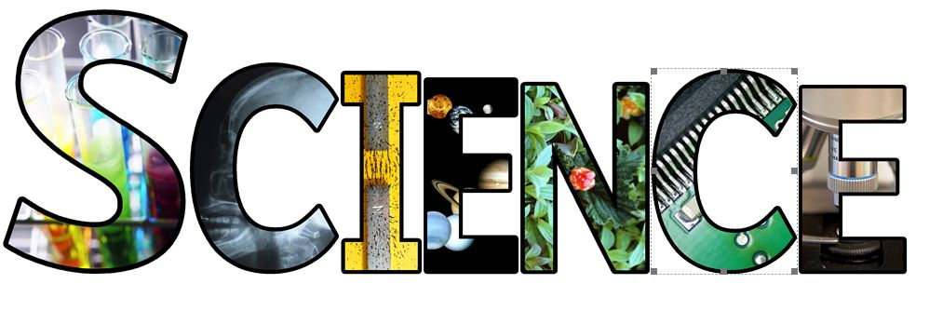
Science is a spark of wonder that ignites a curiosity which takes us on a journey of discovery.
At Chaucer Infant and Nursery School our intent is to promote and nurture curiosity and wonder. Children are encouraged to generate their own questions as well as the skills to finding the answers.
Children do Science to learn Science through practical investigations that create opportunities to develop scientific skills, knowledge, vocabulary and enquiring minds in search of answers.
Our learners adopt a growth mindset attitude and understand that mistakes are a positive part of the journey to discovery.
The importance of respect for the natural world and our position in it is a key element in all Science teaching a long with the recognition that science impacts all aspects of our lives.
By following the footsteps of scientists from the past, children learn how to make their own impact in the future.

Curiosity | Discovery | Impact & Understanding | Respect
What do I want to find out?  What do I think will happen?  Where do I need to look?  Why is it important to find out?  What do I need to help me answer my questions? | I will use my senses  I will explore  I will get things wrong  I will learn from my mistakes  I will test fairly  I will make meaningful observations  I will argue  I will listen  I will respect the views of others  I will explain | What do my findings tell me?  What do I know now that I didn’t know before?  What do I still need to find out?  How will I find out more?  Where can I find similar evidence?  Where can I find contrasting evidence?  How do I feel about my findings? | We are very small in the bigger picture  Where does my new and existing knowledge fit in?  What can I do with my new knowledge?  Can I make a difference?  How valuable is my knowledge?  How do I share my knowledge?

