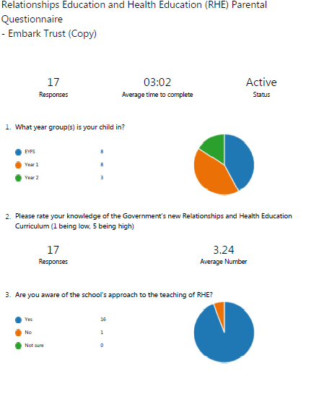
I am happy with the policy and the information it provides me with at this time
I am happy with the policy but have some questions
I would like the opportunity to consult upon the policy

Response 1 | anonymous | Will con Will consent be taught as part of this curriculum? Outer body part proper names are going to be taught, which is fantastic but vagina is the inner part. Would vulva be taught alongside this to describe the outer body part correctly? Also, in response to the last question on this form, there is no such thing as “sexual body parts”. There are reproductive organs, but not sexual.
School response/answer |  | C School Consent is taught as part of the curriculum from Nursery in an age appropriate way. The vocabulary list has been altered to include both terms.
Response 2 | anonymous | I do not believe the school should be teaching children anything to do with sexuality in a primary setting. This should be left to the parents on an individual level.
School response/answer |  | We will not be teaching children anything to do with the promotion of sexual activity. Please refer to Page 2 of the Relationships and Health Education Policy which is on the school website. The teaching of RHE is a partnership between parents and our school. Parents are invited to talk to the Headteacher or child’s class teacher if they have any concerns.

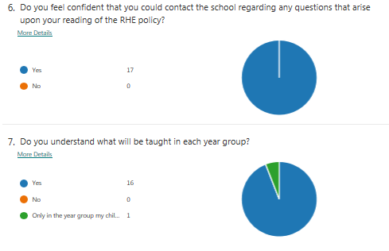
School response/answer | The termly topics/themes will be posted on the school website/Class Dojo to ensure parents know what will be taught to their child/children.

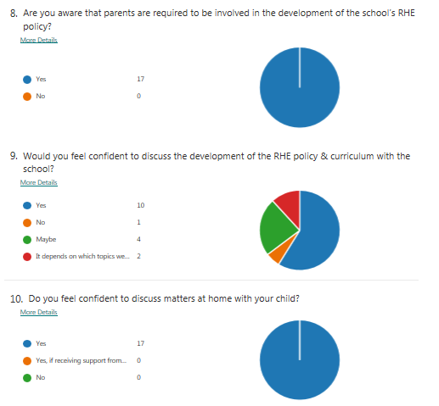

School response/answer | We will give parents the opportunity to view the resources used in school in the next academic year – Covid Guidance permitting.

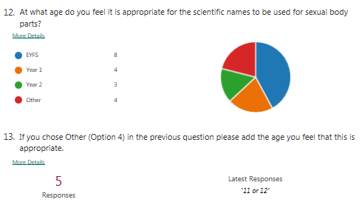
Response 1 | anonymous | Anon10 10
Response 2 | anonymous | I answered with the first answer, however proper body names should be taught alongside any other from as soon as teaching speach with children.
Response 3 | anonymous | I feel it isn’t appropriate to introduce in year 1 but would approve if the children was in juniors for example year 3/4
Response 4 | anonymous | Year 3
Response 5 | anonymous | 11 or 12
School response/  answer | After a discussion with the staff at Chaucer Infant and Nursery School and in consultation with Chaucer Junior School staff a list has been agreed where specific vocabulary will be taught according to year group from Reception to Year 6. This is an important issue in regards to Safeguarding and ensures the same language is used to describe body parts. This will help to avoid misunderstanding/confusion possibly caused by the use of colloquial names.

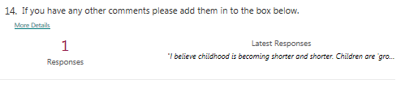
Response 1 | anonymous | I believe childhood is becoming shorter and shorter. Children are ‘growing up’ far too quickly and becoming sexualised more and more often. This is such a mistake, why not let children enjoy childhood for as long as possible? Use that time to teach them more science, maths and english. These are the basics and will help them get ahead in their future careers. Thank you for taking the time to read my input.
School response/  answer | The RHE curriculum is in place to equip children for the ever changing world in which they live (Living in the Wider World). It is not to promote sexual activity. At Chaucer Infant and Nursery School we will be teaching about healthy positive relationships and health and wellbeing.

