In the increasingly technological world we live in, Design and Technology is fundamental in creating the critical thinkers, innovators and designers for an ever changing modern world. Our intent at Chaucer Infant and Nursery School is to inspire children, through a broad range of practical experiences, to create pioneering designs which solve real and relevant problems. Throughout the curriculum, children will evaluate key events and individuals who have helped shape the world.

In Early Years, children begin to develop prerequisite skills for Design and Technology through the prime area of Physical Development and the specific area of learning – Expressive Arts and Design (Creating with Materials). The children use a range of small tools, including scissors, paintbrushes and cutlery and explore a variety of materials, tools and techniques, experimenting with colour, design, texture, form and function. The children share their creations and explain the process they have used.

Following this, the iterative process, where children continually improve a design and product, is fundamental and runs through the school.

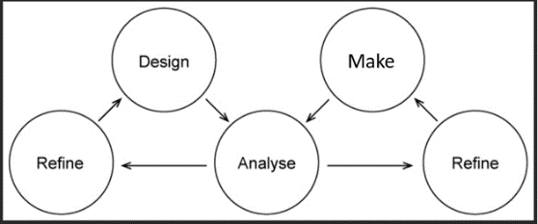

Children will:

* Identify real and relevant problems
* Critically evaluate existing products
* Take risks and innovate when designing and creating solutions to the problems
* Reflect, evaluate and improve on prototypes
* Use set design criteria throughout to ensure a design brief has been met
* Apply technical knowledge throughout a sequence of learning

|  |  |  |  |  |
| --- | --- | --- | --- | --- |
| **Key Learning** | | | | |
| **Appreciation** | **Design** | **Make** | **Evaluate** | **Technical Knowledge** |
| Children will be inspired by engineers, designers, chefs and architects who have already made an impact on the world. Through research, children will appreciate and evaluate existing designs. | Children will design purposeful, appealing products for themselves and others based on design criteria. They will communicate their ideas through age appropriate means such as; models, drawings and prototypes. Children will have an understanding of a healthy diet and understanding of where food comes from to enable them to design dishes. | Children will select from a range of tools and equipment to perform practical tasks. They will select from a wide range of materials and components according to their characteristics. | Children will critique, evaluate and test their ideas, existing products and the work of others against design criteria. They will identify what they find pleasing and effective as well as how work could be improved. | Children will have an age appropriate technical knowledge that will underpin all elements of the Design and Technology curriculum. Children will build structures, exploring how they can be made stronger and more stable. They will explore and use mechanisms in their products. |

***In EYFS this is implemented through:***

* Continuous provision (malleable table, construction area, large construction, pipes, guttering, crates, den building, water, sand, mud kitchen, small world, role play, creative area, junk modelling)
* Photographs
* Snack time (comparison foods and textures)
* Food tasting
* Baking
* Investigation area/question/resources
* Questioning their learning (Can you make the model bigger/wider/stronger/faster?)
* Books and stories

***In KS1 this is implemented through:***

* Food tasting (comparison of foods and textures)
* Questioning their learning
* Photographs for research
* Short film/ video clips for research
* Exploring a design brief
* Using tools safely
* Drawing and modelling their ideas and explain what they are going to do
* Developing their designs through discussion, sketches and written comments
* Developing making skills through a range of focussed practical tasks